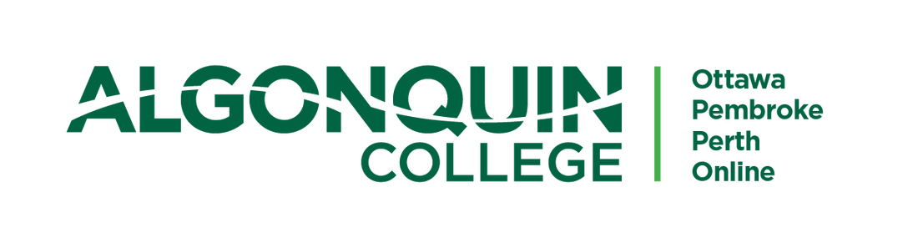

AI-Equipped Educational Chatbot using Ollama and RAG for NLP Basics

Presented By:
Ibrahim Irfan
Redwan Wadud

Table of Contents
Background 3
Team Details 3
Dataset and Procedure 3
Source Data 3
Processing Procedure 4
Plan of Work 4
Expected Results & Significance 5
What Result Do We Hope to Get? 5
Why Is This Interesting? 5

PROJECT PROPOSAL
AI-Equipped Educational Chatbot using Ollama and RAG for NLP Basics
CST8507: Natural Language Processing | Winter 2026
Background
The goal of this project is to design and develop an AI-powered educational chatbot capable of answering questions about Natural Language Processing (NLP) concepts. The system will leverage Ollama, a lightweight local LLM inference framework, combined with a Retrieval-Augmented Generation (RAG) pipeline built on top of curated NLP lecture notes and academic articles.
Students learning NLP often struggle with dense textbook language and lack access to interactive, on-demand tutoring. A domain-specific chatbot that grounds its responses in verified course material addresses this gap by delivering accurate, context-aware explanations without hallucinations. This project is motivated by three key challenges:
- Accessibility: Students need 24/7 access to reliable NLP explanations beyond office hours.
- Accuracy: Generic LLMs hallucinate; RAG anchors answers to authoritative source documents.
- Cost: A local Ollama deployment removes API costs and enables offline classroom use.

Team Details
Name | Role | Responsibilities
Ibrahim Irfan | AI Engineer & Python Developer | Dataset collection, Preprocessing, Evaluation, Python Backend
Redwan Wadud | Full-Stack Developer | RAG pipeline, Ollama Integration, Embeddings, Chat UI

Dataset and Procedure

Source Data
- NLP Lecture Notes: Curated slide decks and typed notes from NLP courses (e.g., Algonquin College, CST8507) covering tokenization, embeddings, transformers, and sequence models.
- Academic Articles (Optional): Seminal NLP papers (Word2Vec, BERT, GPT, Attention Is All You Need) sourced from arXiv and ACL Anthology.
- Textbook Excerpts (Optional): Open-access chapters from Speech and Language Processing (Jurafsky & Martin, 3rd Ed.) relevant to core NLP topics.

Processing Procedure
- Gather PDFs, markdown notes, and HTML articles, store in a structured directory.
- Split documents into 300–500 token overlapping chunks using LangChain text splitters.
- Encode chunks with a sentence-transformer model (e.g., all-MiniLM-L6-v2) and index in ChromaDB.
- At query time, embed user question and retrieve top-k relevant chunks via cosine similarity.
- Feed retrieved context + question to Ollama (LLaMA 3 / Mistral) to synthesize a grounded answer.

Plan of Work
Milestone | Target Date
PART 1 — RAG Implementation
M1 — Topic Selection & Environment Setup: Conda env, Ollama install & model pull (qwen2.5:0.5b) | Days 1–3
M2 — Data Collection & Preprocessing: Gather NLP lecture notes/articles, clean & tokenize text | Days 4–7
M3 — RAG Pipeline: Chunking, sentence-transformer embeddings, ChromaDB vector index | Days 8–13
M4 — Ollama Integration & Prompt Engineering: Ground responses in document context only | Days 14–17
M5 — User Interface: Streamlit/Gradio UI with question input, answer display & source citations | Days 18–20
M6 — Evaluation: 20-question QA test set, accuracy scoring, top-3 doc retrieval assessment | Days 21–23
M7 — OOP Refactoring: Convert RAG code to class-based structure ready for ROS2 conversion | Days 24–25
PART 2 — ROS2 Node Integration
M8 — ROS2 Setup: Create knowledge directory, add ollama_publisher.py to aisd_hearing package | Days 26–27
M9 — Node Development: Subscribe to 'words' topic (Whisper), publish to 'ollama_reply' topic | Days 27–28
M10 — Build & Integration: Update setup.py entry points, colcon build, connect gTTS to ollama_reply | Days 29–30
M11 — Full Pipeline Testing & Final Report | Day 31

Expected Results & Significance

What Result Do We Hope to Get?
We aim to deliver a fully functional educational chatbot that correctly answers NLP concept questions grounded in the provided corpus, targeting an average accuracy score above 0.80 based on a 20-question manual evaluation with human-annotated answers. The system should support conversational follow-ups and produce concise explanations suitable for undergraduate learners. Key output artifacts include:
- A working RAG pipeline with ChromaDB + sentence-transformer embeddings.
- An Ollama-backed Llama 3 / Mistral inference engine running locally.
- A Streamlit chat interface with source citation for each answer.
- A quantitative evaluation report comparing RAG vs. baseline (no retrieval) responses.

Why Is This Interesting?
This project sits at the intersection of practical LLM engineering and educational technology. It demonstrates how RAG can tame LLM hallucinations in a domain where accuracy is critical so students should not learn incorrect NLP definitions. Running entirely on Ollama makes the solution cost-free, privacy-preserving, and reproducible, which is especially valuable in academic settings. Beyond the course, this architecture is directly transferable to any specialised knowledge domain, making it a strong portfolio piece for NLP and MLOps careers.

